A000-Eur-Czech Republic-Dolní Věstonice-Figurine-Mammoth-Ceramic-29,000-22,000 BP 2

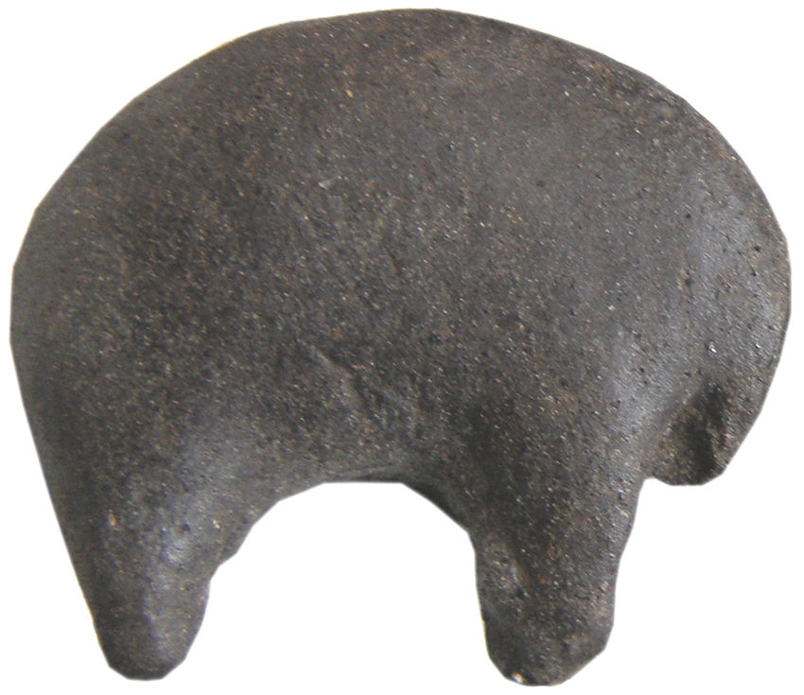

Fig. 1. Czech Republic-Dolní Věstonice-Figurine-Mammoth-Ceramic-29,000-22,000 BP

**Formal Label:** Czech Republic-Dolní Věstonice-Figurine-Mammoth-Ceramic-29,000-22,000 BP **Display Description:** This ceramic mammoth from Dolní Věstonice, Moravia, in the Czech Republic, was found on the hill of Pollau 549 m (1,801 ft) asl, and was dated to 26,000 BP. This site has been a source of 10,000 ceramic fragments of the Gravettian period (27,000-20,000 BP).

**Accession Number:**

**LC Classification:** GN772.22.C95

**Date or Time Horizon:** 29,000-22,000 BP

**Geographical Area:** Moravia in the Czech Republic, on the hill of Pollau.

**Map, GPS 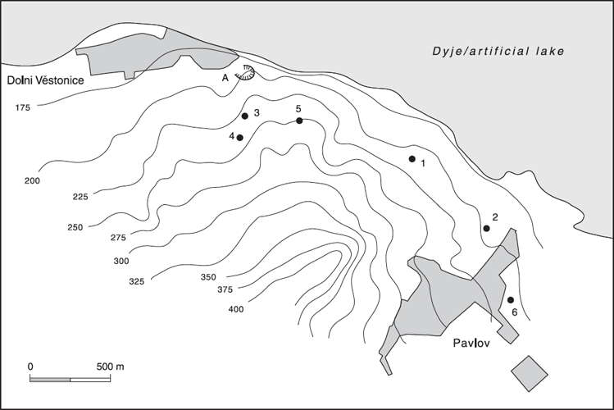Coordinates:** 48.88826 16.64364.

Fig. 2. Relief map showing Upper Paleolithic sites along the northeast side of the Pollau Hill. Dark line is the Dyje River. After Verpoorte (2000). Key: 1. Dolní Věstonice I; 2. Pavlov I; 3. Dolní Věstonice II; 4. Dolní Věstonice II-A; 5. Dolní Věstonice III; 6. Pavlov II.

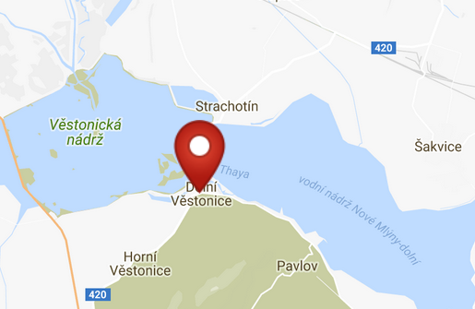 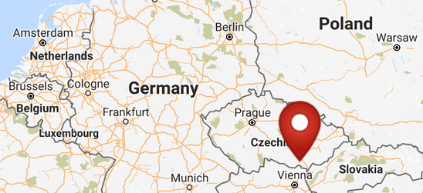

Fig. 3. Map of Dolni Vestonici. Fig. 4. Location of Dolni Vestonici in Europe.

Fig. 5. Map of Dolni Vestonici within Europe. After <http://latitude.to/img/latitude-logo.svg>

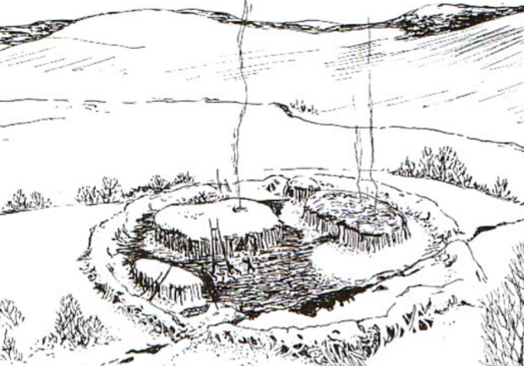

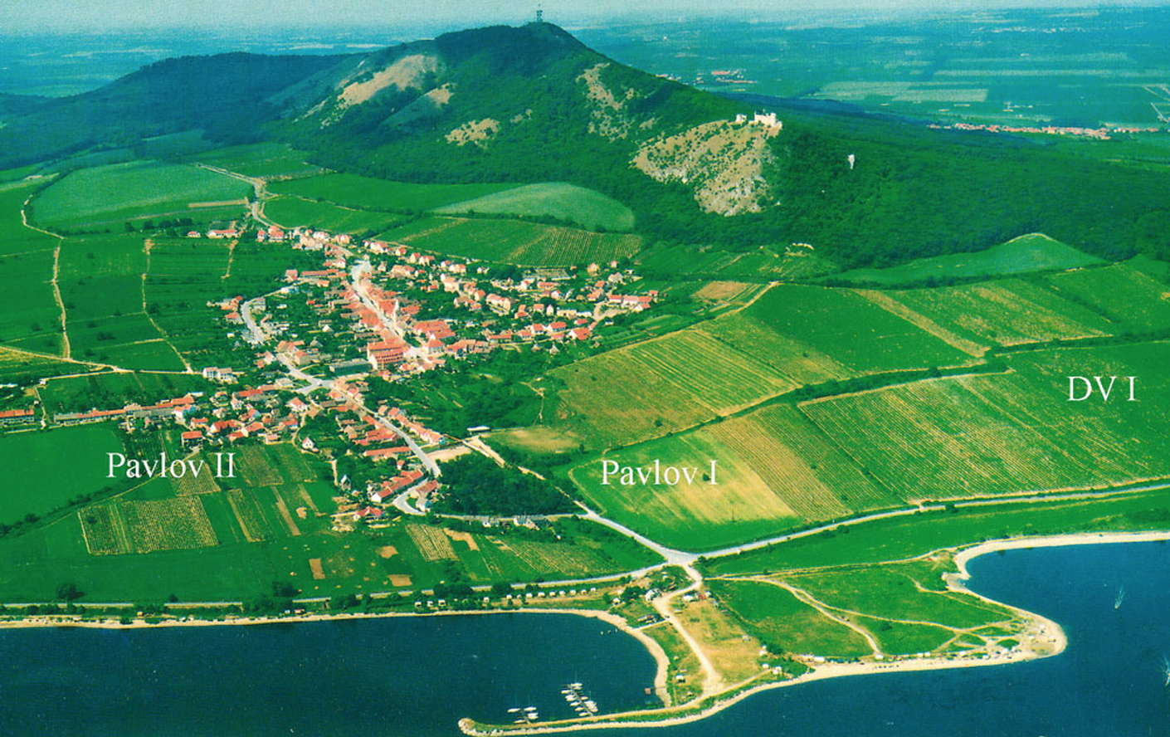

Fig. 6. View of Dolní Věstonice, Moravia, Czech Republic, 29,000 BP, after <http://humanpast.net/images/dolni.JPG>.

Fig. 7. Aerial view of Dolní Věstonice, Moravia, Czech Republic, 2004, after Svoboda (2007)

**Cultural Affiliation:** Gravettian period

**Medium:** ceramic.

**Dimensions:   
Weight: original, unknown.**

**Provenance:**

**Condition:** museum replica in resin.

**Discussion:**

Dolní Věstonice, Moravia, Czech Republic, is located on Pollau Hill, 549 m (1,801 ft) asl, and dates to the Gravettian period (28,000 BP-24,000 BP). This abstract ceramic sculpture of a mammoth provides a glimpse into a precocious Upper Paleolithic ceramic technology that depicted the animal as an artistic, non-utilitarian entity and not as a rationalistic entity.

The sites of Dolni Vestonice and Pavlov have yielded more than 10,000 fragmentary ceramics, an assemblage that substantiates an Upper Paleolithic ceramic technology that never produced pottery. Dolni Vestonice, Pavlov, and Predmosti are actually part of the same Paleolithic culture that occupied these sites between 28,000 and 24,000 years B.P.

The figurines probably were not considered to be permanent portable artifacts because the 10,000 broken artifacts fractured in the firing process suggests that the act of firing these ceramics and watching them explode was the reason for their creation. Furthermore, since the kilns in which this thermal shock occurred was located a considerable distance upslope from the settlement area, suggests that the act of creating these figurines was the product of a small number of people of the community.

**References:**

Trinkaus, Erik and Jiri Svoboda (Eds.) 2005.*Early Modern Human Evolution in Central Europe: The People of Dolní Vestonice and Pavlov* (Human Evolution Series). New York: Oxford University Press.

Vandiver, Pamela B., Olga Soffer, Bohuslav Klima and Jiři Svoboda. 1989. “The Origins of Ceramic Technology at Dolni Věstonice, Czechoslovakia,” *Science*, New Series, 246, No. 4933 (Nov. 24), pp. 1002-1008.